|  |
| --- |
| File:Conidiophore of the fungus Bipolaris hawaiiensis PHIL 4338 lores.jpg  (<http://phil.cdc.gov/phil_images/20030728/9/PHIL_4338_lores.jpg>)Photo by David B. Langston, University of Georgia, Bugwood.org  [View in Bugwood Image Database](http://images.bugwood.org/imgdirect.cfm?img=5076064) |
| **Taxonomy** |
| |  |  | | --- | --- | | Kingdom: | Fungi | | Phylum: | Ascomycota | | Class: | Dothideomycetes | | Order: | Pleosporales | | Family: | Pleosporaceae | | Genus: | *Bipolaris* | | Species: | *hawaiiensis* | |
| **Scientific Name** |
| **Bipolaris hawaiiensis**  (J.Y. Uchida and Aragaki et al 1969) |
| **Teleomorph** |
| **Cochliobolus hawaiiensis**  ***Alcorn 1978*** |
|  |
| **Common Names and Diseases** |
| Leaf spot and blight |

# *Bipolaris Hawaiiensis*

Jump to: [navigation](http://wiki.bugwood.org:80/#mw-head), [search](http://wiki.bugwood.org:80/#p-search)

|  |
| --- |
|  |

**Author: Ashish Adhikari, University of Florida**

|  |
| --- |
| Contents  * [1 Pathogen](http://wiki.bugwood.org:80/#Pathogen) * [2 Symptoms and Signs](http://wiki.bugwood.org:80/#Symptoms_and_Signs) * [3 Ecology and Spread](http://wiki.bugwood.org:80/#Ecology_and_Spread) * [4 Geographic Distribution](http://wiki.bugwood.org:80/#Geographic_Distribution) * [5 Management](http://wiki.bugwood.org:80/#Management) * [6 Diagnostic procedures](http://wiki.bugwood.org:80/#Diagnostic_procedures) * [7 Resources and References](http://wiki.bugwood.org:80/#Resources_and_References) |

# Pathogen

*B. hawaiiensis* is a common pathogen of grass hosts and turf in tropical and sub tropical regions. Anamorphic state is abundant than teliomorph state. It is recently moved to Genus *Curvularia*. It has simple septate unbranched conidiophore producing thick wall, melanized, distoseptated (3 to 7 septa), cylindrical or fusiform shaped conidia.

# Symptoms and Signs

# The pathogen can cause leaf spots, blight, crown and stem rot (melting out), and root rot of grasses. In warm regions, it can cause leaf spots or blight and crown rot all-round the years. However, in cool regions, leaf spots and blight symptoms are cause during warm and wet period. The symptom get worse as the temperature raises from 25 to 30degree celsius.anthracnose (Colletotrichum orbiculare) symptoms on watermelon (Citrullus lanatus)

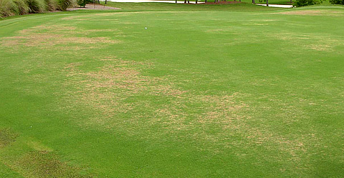 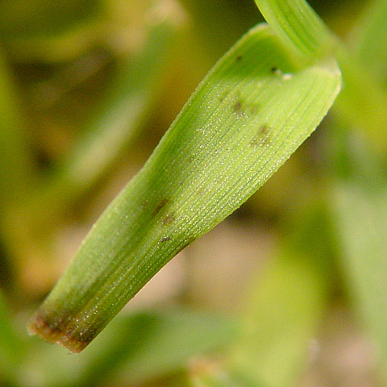

(Brecht et al 2007)

Photo by Gerald Holmes, Valent USA Corporation, Bugwood.org

[View in Bugwood Image Database](http://images.bugwood.org/imgdirect.cfm?img=1577301)

# Ecology and Spread

The pathogen survives as a saprophyte in the form of conidia in soil and dormant mycelium in plant debris. Both conidia and dormant mycelium can serve as primary source of inoculum and can penetrate the host through natural openings or directly through the epidermal wall by forming a appressorium. The fungus produces some toxin that interfere with host cellular processes and allows pathogen to reproduce and colonized the host, however, it is not able to kill the host. At the end of the growing season, the fungus produces asexual fruiting body or dormant mycelium to survive the winter.

# Geographic Distribution

The pathogen has worldwide distribution. It is a widespread problem of grasses and turfs in humid and warm regions.

# Management

* Sanitation: Cleaning of plant residues and dead tissues.
* Soil solarization.
* Proper drainage facility.
* Use of fungicides to prevent the disease.
* Consult your local extension specialist for legal and efficacious fungicide products available in your state. Remember, the label is the law and the product applicator is responsible for reading and following all chemical labeling.

# Diagnostic procedures

The diseased or symptomatic tissue samples can be incubated at high relative humidity which facilitates in sporulation of fungus.

Diagnostic features:

* Black melanized, septate hyphae.
* Conidiophore is simple, unbranched, symmpodia.
* Conidia are blacck or brown, septate, cylindrical to fusiform, distosepta (3 to 7) and 18-35* 6-9 micrometers.

The fungus can grow well in water agar and potato dextrose agar.

Molecular diagnostic methods are available, see Phytopathology 97:1305-1314.

# Resources and References

Brecht, M. O., Stiles, C. M., & Datnoff, L. E. (2007). Evaluation of pathogenicity of Bipolaris and Curvularia spp. on dwarf and ultradwarf bermudagrasses in Florida. *Plant Health Prog*.

Manamgoda, D. S., Rossman, A. Y., Castlebury, L. A., Crous, P. W., Madrid, H., Chukeatirote, E., & Hyde, K. D. (2014). The genus bipolaris. *Studies in Mycology*, *79*, 221-288.